"Ideation is the mode of the design process in which you concentrate on idea generation. Mentally it represents a process of "going wide" in terms of concepts and outcomes. Ideation provides both the fuel and also the source material for building prototypes and getting innovative solutions into the hands ofyour users. "

By now, you've probably heard about design thinking. More industries than ever are taking a human-centric approach to evolve their existing products and generating new ideas to serve their customers better. Let's take a closer look at what design thinking is and how to apply it to your organization.

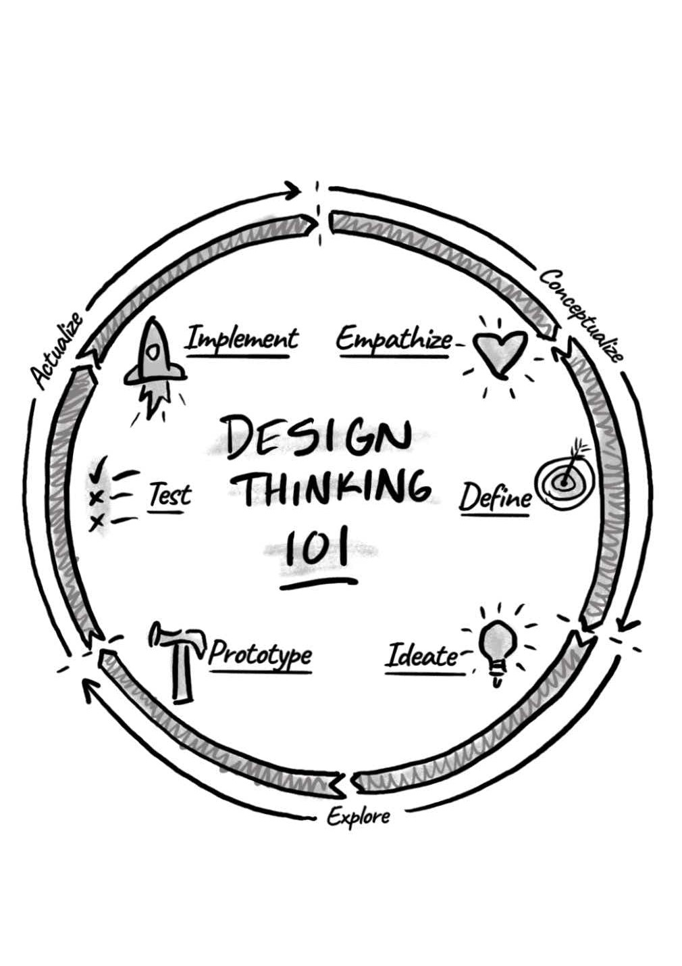

The method is steeped in a deep belief that the end-user should be at the heart of all decision-making. The benefit of design thinking is that, through empathy for your customer, consumer, or client, you are able to create products and experiences that truly help people and even change lives.

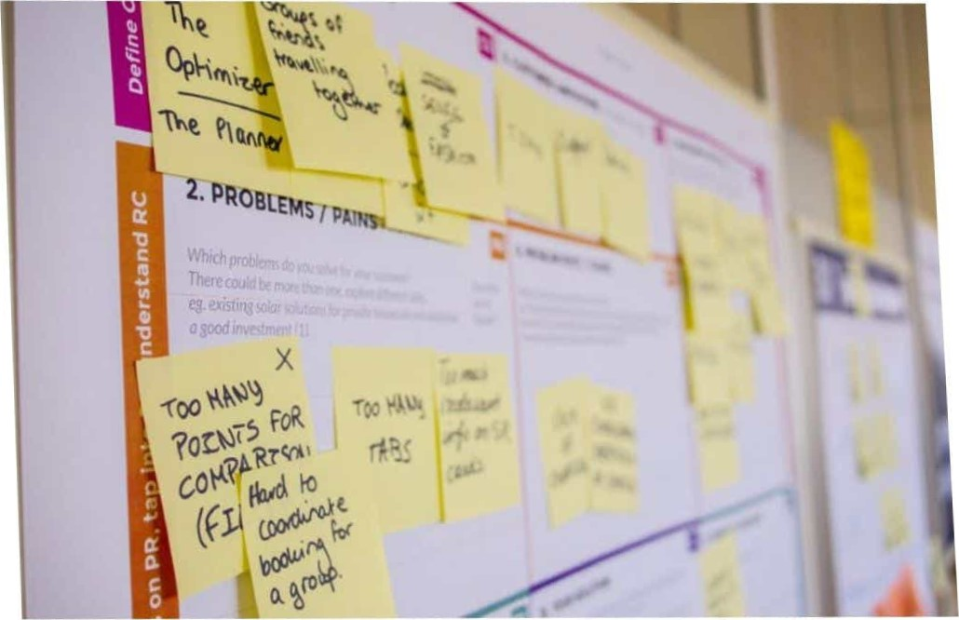

Explore solutions and think out-of-the-box in the ideation phase of the design thinking process.

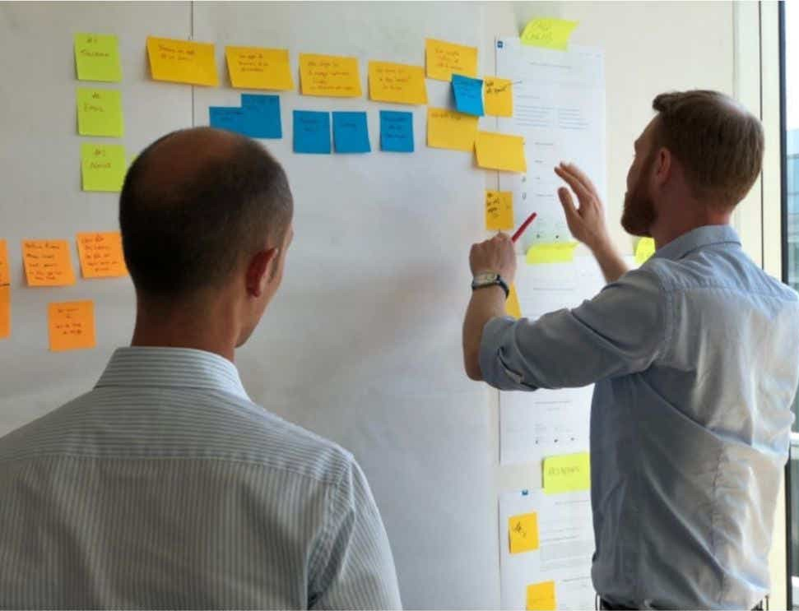Define your problem statement clearly: group and cluster ideas together until you find the prevailing or most prominent themes.

The first stage of the design process is to understand the perspective of the target audience/customer/consumer to identify and address the problem at hand. To do this, design thinkers are encouraged to cast aside all assumptions (because assumptions can stifle innovation!) about the problem, the consumers, and the world at large. This allows them to objectively consider any and all possibilities about the customers and their needs.

* Recipe, product, and menu development (including limited time offers) - Above-trend, onbudget ideas and development
* Restaurant audit -A comprehensive restaurant audit can turn around a struggling business and increase the bottom line for a successful one
* Guest-facing - Menus, signage, fixtures, elevation design elements, and fabricators for an effective guest experience
* Kitchen layout - Kitchen and service area layout and design including the selection of equipment, fixtures, and furniture